Name ___________________________ AP Calculus
Section 7.1 Practice: Integral as net change

Show all your work!

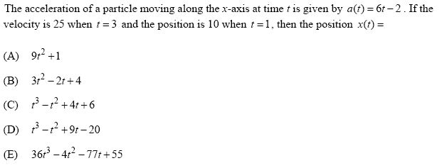
1.

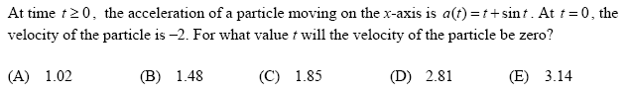
2.

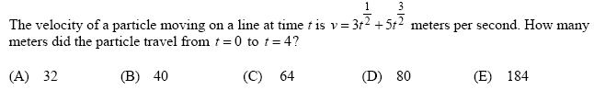
3.

4.
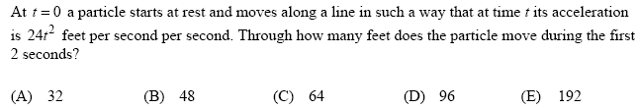

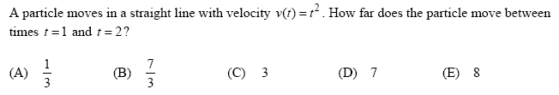
5.

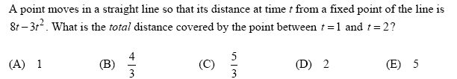
6.

